

**PALO ALTO LICENCE + UPDATING**

****Brendon Ahn | Cybersecurity | 2022-2023

**Purpose**

To make our Palo Alto Firewall up to date with current licenses and updates

**Background**

Palo Alto releases updates that not only improve the GUI but also adds the latest security features. How you update is first you have to get the licenses and then you can retrieve the software updates. You have to be connected to internet to retrieve the licenses first. Then you start the long arduous process of going through all the updates. Each take a very long time because the 220s aren’t very fast.

Knowing how to update Palo Alto to the latest edition is essential for anybody working with the firewalls to know how to do. Keeping the software up to date and getting new lists and such will only make a more secure network. Software update can also deal with quality of life and update the GUI vastly.

In order to update you have to follow a certain order. You can’t go directly from 8.0.0 to 12.0.0 you have to go from 8.0.1 to 8.0.9 to 8.1.0 to 8.1.9 so on so forth. That is one of the reasons why this process could take so long. Each update may take around 10 minutes and then another 10 minutes to restart the firewall which you have to do in between every update.

**Lab Summary**

We had to retrieve licenses and then update the software to the latest version on a Palo Alto 220

**Lab Procedure**

1. Go to device – license and click retrieve license keys

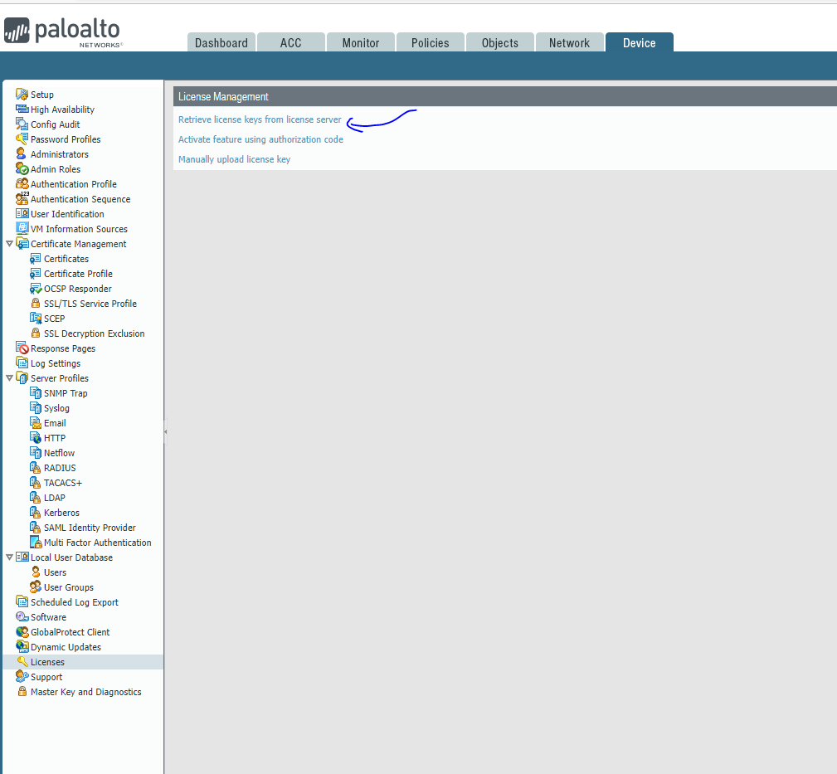

1. Go to device – software and click Check Now

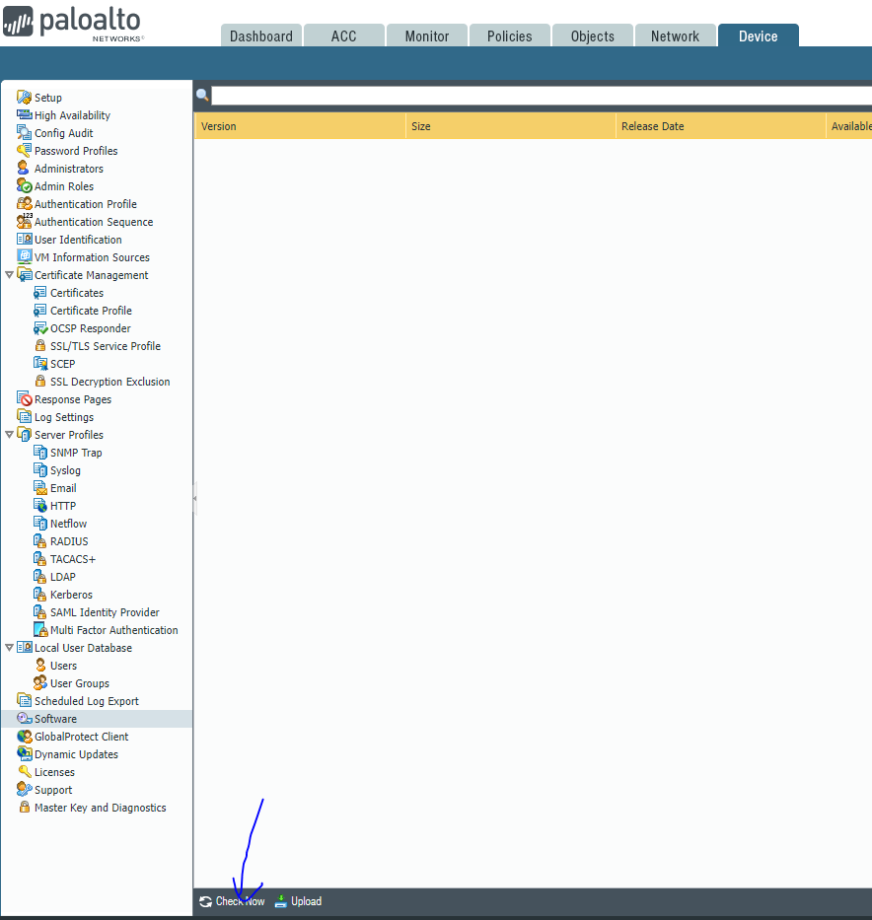

1. Update to the latest version (ex 8.0.1 to 8.0.9 to 8.1.0 to 8.1.9 etc.)

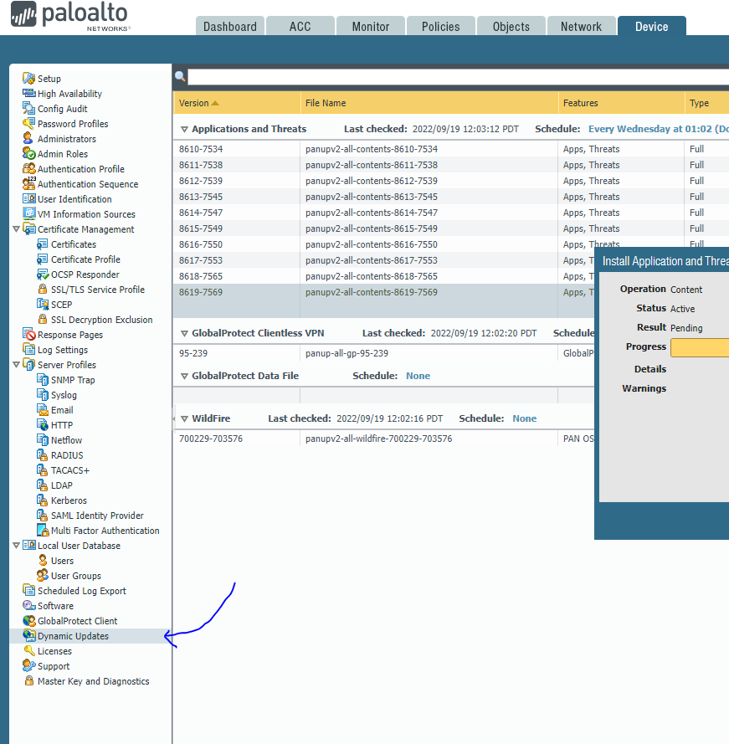

1. Download these as well

Highest number for this one





**Problems**

We forgot an update in order to do one of the updates. We were unaware of the update being necessary. It also just took an unholy amount of time to just get through the updates. At the beginning we struggled to get the license because are firewall wasn’t connecting to the internet, so the SOHO lab had to be gone over again.

**Conclusion**

In conclusion we spent a lot of time updating and getting licenses in order to bring the PA 220 to the latest version. Besides the basic software updates there are two updates you need to do in order to make it the latest versions and then you just go through the process of bringing it to thel attest.